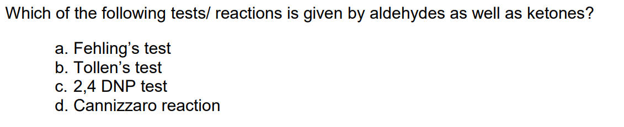

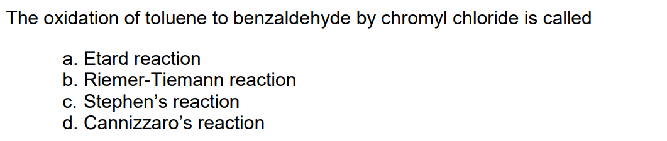

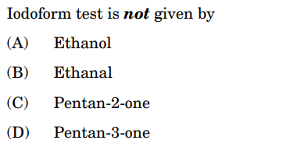

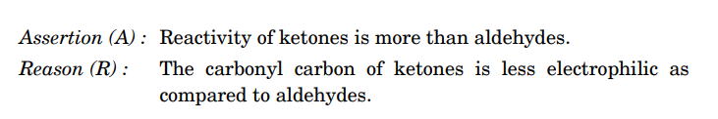
- Both Assertion and reason are true and reason is the correct explanation of the assertion.
- Both Assertion and reason are true and reason is not the correct explanation of the assertion.
- Assertion is true but Reason is false.
- Assertion is false but Reason is true.

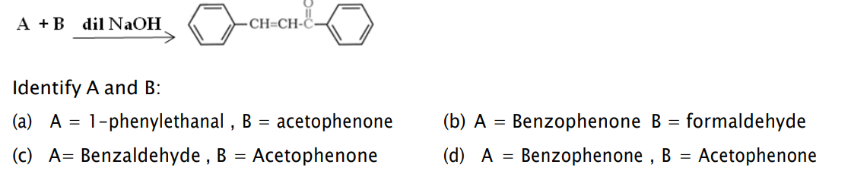

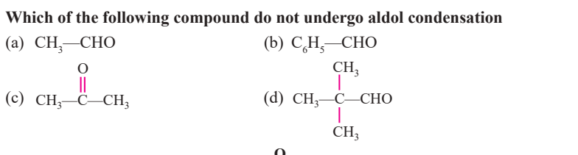
SECTION B [ 2 marks]

